Tree.h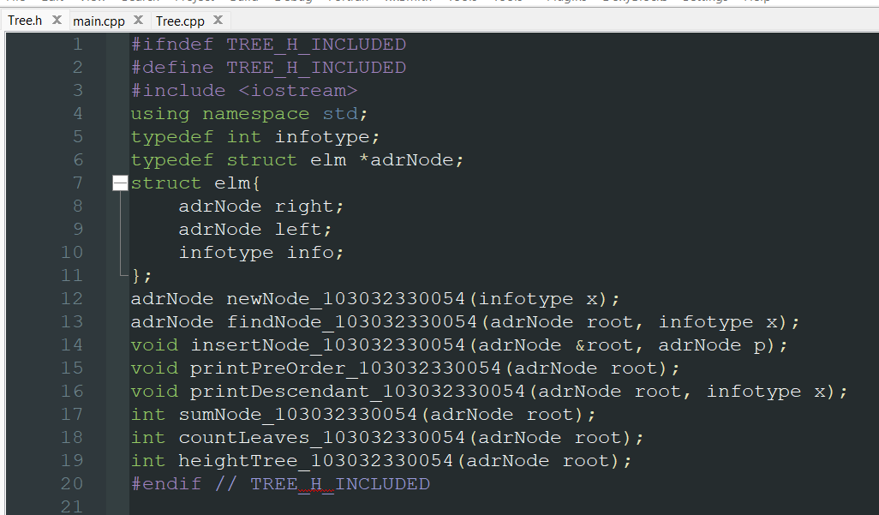

Output

